***HOTEL ROOM BOOKING SYSTEM***

**Project report submitted in partial fulfillment of the Requirements for the Award of the Degree of**

**BACHELOR OF TECHNOLOGY**

**In**

**COMPUTER SCIENCE AND ENGINEERING**

**By**

**NAME ROLL NUMBER**

**N.SAI PRAVALIKA 24KB1A05BP**

**N. ANUSHKA 24KB1A05BF**

**N.RUPA SRI 24KB1A05BV**

**N. DIVYA LAKSHMI 24KB1A05CF**

**Under the Guidance of**

**MRS.SRUTHI.B**

**DEPARTMENT OF COMPUTER SCIENCE**

**N.B.K.R INSTITUTE OF SCIENCE AND TECHNOLOGY**

**(AUTONOMOUS)**

**DEPARTMENT OF COMPUTER SCIENCE AND ENGINEERING**

**

###### CERTIFICATE

This is to certify that the project report entitled YOUR PROJECT TITLE being submitted by

N. SAI PRAVALIKA 24KB1A05BP

N. ANUSHKA 24KB1A05BV

N. RUPA SRI 24KB1A05BF

N.DIVYA LAKSHMI 24KB1A05CF

*in partial fulfillment for the award of the Degree of Bachelor of Technology in Computer Science and Engineering to the is a record of bonafied work carried out under my guidance and supervision*.

|  |  |
| --- | --- |
| **MRS.SHURTHI.B**  **Designation** | **Dr. RAJASHEKAR REDDY**  **M.Tech, Ph.D**  **Head of the Department** |

***DECLARATION***

I hereby declare that the dissertation entitled **HOTEL ROOM BOOKING SYSTEM** submitted for the B.Tech Degree is my original work and the dissertation has not formed the basis for the award of any degree, associateship, fellowship or any other similar titles.

Place: VIDYANAGAR N.SAI PRAVALIKA 24KB1A05BP

N.ANUSHKA 24KB1A05BF

Date:05/05/2025 N.RUPASRI 24KB1A05BV

N.DIVYA LAKSHMI 24KB1A05CF

ACKNOWLEDGEMENT

I would like to express my sincere gratitude to all those who helped me successfully complete this project on **"Hotel Room Booking System in C Language."**

First and foremost, I thank , MRS.B.SRUTHI my project guide, for providing valuable guidance, support, and encouragement throughout the development of this project. Their insights and suggestions were instrumental in shaping the structure and logic of the program.

I also wish to extend my appreciation to my institution and faculty members for creating an environment conducive to learning and experimentation.

Special thanks to my friends and family for their constant motivation and assistance during the development and testing phases of the system.

Lastly, I am grateful for the various online resources, forums, and documentation that helped me overcome technical challenges and gain a deeper understanding of C programming concepts.

This project has significantly contributed to my practical knowledge of the C language and enhanced my problem-solving and software development skills

### 

### ABSTRACT

The Hotel Room Booking System is a console-based application developed in the C programming language to manage hotel reservations in a simplified and efficient manner. This system allows users to book rooms, check room availability, view customer details, and manage check-ins and check-outs. The program uses basic file handling to store and retrieve data, ensuring that booking information is preserved even after the program is closed. It provides an interactive menu-driven interface for ease of use, simulating real-world hotel booking operations. This project serves as an educational exercise to implement structured programming, file management, and user interface design using the C language.

**CONTRIBUTIONS**

**Design & Planning**: Structured the flow of the application, including user interface layout and menu options.

**Core Programming**: Developed all primary modules such as room booking, cancellation, and check-in/check-out using C.

**File Handling**: Implemented file I/O to save and retrieve customer and room details persistently.

**Error Handling**: Added input validation and error checks for invalid data entries to improve reliability.

**Testing & Debugging**: Conducted thorough testing to identify and fix logical and runtime errors.

**Documentation**: Created detailed project documentation to explain the code structure and system functionality.

### 

***TABLE OF CONTENTS***

### SL .NO TOPIC PAGE NO

### 1 INTRODUCTION 1 – 2

### 2 SYSTEM OVER VIEW 3 – 4

### 3 FUNCTIONALITY 4 - 5

### 4 CODE FLOW 6 - 7

### 5 CONCLUSION 7 - 8

***INTRODUCTION***

The **Hotel Room Booking System** is a console-based project developed in the C programming language that simulates the basic functionality of a real-world hotel management system. This project is designed to help understand core C programming concepts such as structures, arrays, linked lists, dynamic memory allocation, and user input handling.

In this system, hotel **room data** is managed using an array, where each element represents a room with properties such as room number and room type. This fixed-size array allows efficient access to and identification of rooms by their index, simplifying the process of assigning and searching for rooms.

To handle **guest bookings**, the project uses **linked lists**. Each room maintains a linked list of bookings, with each booking containing the guest’s name and the duration of their stay. The use of linked lists enables the system to store a variable number of bookings per room dynamically, allowing easy addition of new bookings without requiring pre-allocation of memory.

*SYSTEM OVER VIEW*

This section outlines how the hotel system is logically structured in the program:

* The hotel has **5 rooms**, each assigned a unique room number starting from **101 to 105**.
* Rooms are categorized into three types:
  + **Single** rooms (Rooms 101, 102)
  + **Double** rooms (Rooms 103, 104)
  + **Suite** (Room 105)  
    This classification helps to simulate a realistic hotel room setup and demonstrate how different room types can be handled in code

**FUNCTIONALITY**

Here, we dive into what the program does:

* **Room Initialization (initializeRooms)**:
  + Sets up room numbers and types.
  + Initializes the booking pointers to NULL.
* **Room Booking (bookRoom)**:
  + Adds a new booking to the beginning of the booking list for a given room.
  + Takes the guest's name and duration as input.
* **Booking Display (displayBookings)**:
  + Loops through all rooms.
  + Prints each room’s type and current bookings (if any).

Each function plays a specific role in managing and presenting the hotel data.

***CODE FLOW***

This section explains how the logic flows:

* The main function starts by initializing all rooms.
* Then it enters a loop showing a menu with three choices.
* Based on the user's input, it either adds a booking, displays bookings, or exits.
* Bookings are stored in linked lists, so multiple entries per room are possible.

This modular flow is easy to follow and maintain, which is critical for larger projects.

**CONCLUSION**

Summarizes what the project achieved:

* Created a working hotel booking system using C.
* Applied key programming concepts like structures and dynamic memory.
* Built a foundation for more advanced booking systems.  
  This project is a practical demonstration of how simple tools in C can model real-world problems.

### *SOFTWARE REQUIREMENT ANALYSIS*

**Functional Requirements**:

* The system shall allow the user to initialize 5 rooms with different room types.
* The system shall enable booking a room by entering room number, guest name, and duration.
* The system shall store multiple bookings per room using a linked list.
* The system shall allow the user to view all current bookings in the hotel.
* The system shall provide a menu with options to book, display, or exit.

**Non-Functional Requirements**:

* The system must be simple and responsive with a user-friendly CLI (Command-Line Interface).
* The system must be efficient in terms of memory usage.
* The system must be modular, with separate functions for each operation.
* Data persistence is not required (data will not be saved between sessions).

SOFTWARE DESIGN

***1. Requirements***:

Search available rooms

Book/cancel a room

Manage customer details

Admin can add/remove rooms

***2. Main Components***:

User Interface (UI): For customers and admins

Booking Service: Handles search, booking, cancellation

Room Management: Adds, updates, removes room info

Customer Management: Stores customer details

Database: Stores rooms, bookings, customers

***3. Key Classes*:**

Room (roomNumber, type, price, isAvailable

Customer (name, contact, ID)

Booking (bookingID, customer, room, dates)

BookingService (searchRooms(), bookRoom(), cancelBooking())

Admin (addRoom(), removeRoom())

***4. Flow Example:***

1. Customer searches rooms

2. System shows available rooms

3. Customer selects room, enters details

4. System creates booking, updates room status

**CODE**

include <stdio.h>

#include <stdlib.h>

#include <string.h>

#define MAX_ROOMS 5

#define NAME_LENGTH 50

typedef struct Booking {

char

guestName[NAME_LENGTH]

; int duration;

struct Booking* next;

} Booking;

typedef struct {

int roomNumber;

char roomType[20];

Booking* bookings;

} Room;

Room hotel[MAX_ROOMS];

void initializeRooms() {

int i;

for (i = 0; i < MAX_ROOMS; i++) {

hotel[i].roomNumber = 101 + i;

if (i == 0 || i == 1)

strcpy(hotel[i].roomType, "Single");

else if (i == 2 || i == 3)

strcpy(hotel[i].roomType, "Double");

else

strcpy(hotel[i].roomType, "Suite");

hotel[i].bookings = NULL;

}

}

void bookRoom(int roomNum, char* guestName, int duration)

{

for (int i = 0; i < MAX_ROOMS; i++) {

if (hotel[i].roomNumber == roomNum) {

Booking* newBooking = (Booking*)malloc(sizeof(Booking));

strcpy(newBooking->guestName, guestName);

newBooking->duration = duration;

newBooking->next = hotel[i].bookings

; hotel[i].bookings = newBooking;

printf("Booking successful for %s in Room %d\n", guestName, roomNum); return;

}

}

printf("Room %d not found.\n", roomNum);

}

void displayBookings()

{

for (int i = 0; i < MAX_ROOMS; i++)

{

printf("Room %d (%s):\n", hotel[i].roomNumber, hotel[i].roomType);

if (hotel[i].bookings == NULL)

{

printf(" No bookings.\n");

}

else {

Booking* current = hotel[i].bookings;

while (current != NULL)

{

printf(" Guest: %s, Duration: %d days\n", current->guestName, current->duration);

current = current->next;

}

}

}

}

int main()

{

int choice;

char name[NAME_LENGTH];

int roomNum, days;

initializeRooms();

do {

printf("\nHotel Booking System\n");

printf("1. Book a Room\n");

printf("2. Display All Bookings\n");

printf("3. Exit\n");

printf("Enter your choice: ");

scanf("%d", &choice);

getchar();

switch (choice) {

case 1:

printf("Enter Room Number: ");

scanf("%d", &roomNum);

getchar();

printf("Enter Guest Name: ");

fgets(name, NAME_LENGTH, stdin);

name[strcspn(name, "\n")] = '\0';

printf("Enter Duration (days): ");

scanf("%d", &days);

bookRoom(roomNum, name, days);

break;

case 2:

displayBookings();

break;

case 3:

printf("Exiting...\n");

break;

default:

printf("Invalid choice.\n");

}

}

while (choice != 3);

return 0

} ;

**OUTPUT:**

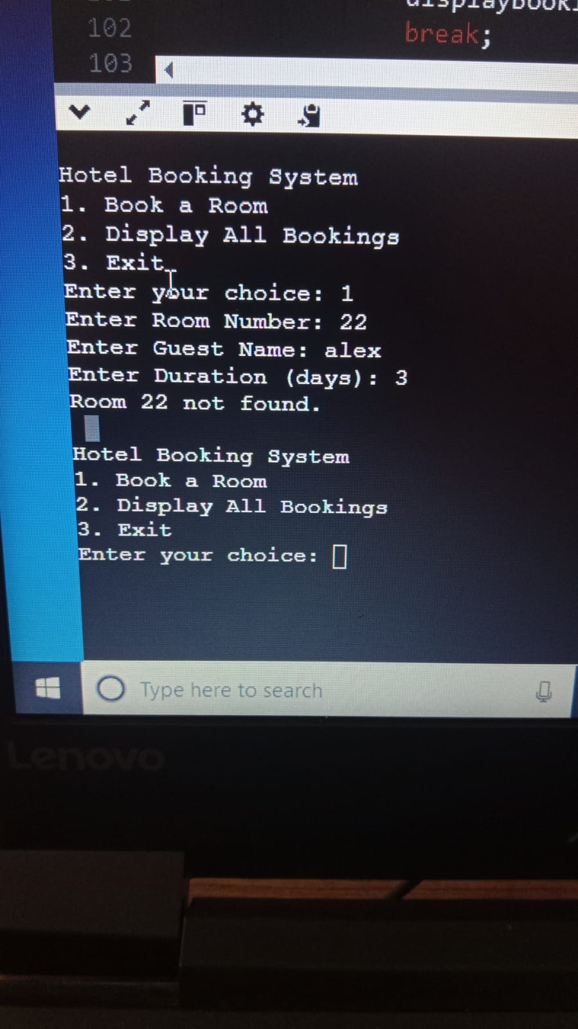

CONCLUSION

The Hotel Room Booking System project successfully streamlines the reservation process by offering a user-friendly interface for customers to check availability, book rooms, and manage their bookings efficiently. It also provides administrators with tools to manage room inventory, track reservations, and generate reports. The implementation of this system enhances operational efficiency, reduces manual errors, and improves customer satisfaction by offering a convenient and reliable booking experience. Overall, the project achieves its objectives and demonstrates the effective use of technology in modern hospitality management.

REFERENCES

1. Sommerville, I. (2016). Software Engineering (10th ed.). Pearson Education.

2. Pressman, R. S., & Maxim, B. R. (2014). Software Engineering: A Practitioner's Approach (8th ed.). McGraw-Hill Education.

3. W3Schools. (n.d.). HTML, CSS, JavaScript, PHP Tutorials. Retrieved from https://www.w3schools.com

4. MySQL Documentation. (n.d.). MySQL 8.0 Reference Manual. Retrieved from https://dev.mysql.com/doc/

5. Stack Overflow. (n.d.). Community Discussions and Code Examples. Retrieved from <https://stackoverflow.com>

6. GitHub. (n.d.). Open-source hotel booking system projects. Retrieved from https://github.com

**THANK YOU……………………**